CODE OF GOOD CONDUCT IN GROUND HANDLING
FOR PERSONS WITH DISABILITIES AND PERSONS WITH REDUCED MOBILITY
TRAVELLING BY PLANE

Table of Content:
Definitions 2
Airline Codes to specify types of assistance andspecial needs of passengers with disabilities and passengers with reduced mobility (according to the IATA) 3
Chapetr 1: Introduction 4
Chapetr 2: General rules 4
Chapter 3: Staff training 7
Chapter 4: Quality Monitoring 8
Chapter 5: Pre-Journey 8
Chapter 6: Getting to the Lodz Airport 10
Chapter 7: Acces to the Terminal Facilities 11
Chapter 8: Disembarking, Assistance to the Terminal, Leaving the airport 14
Attachment 16

DEFINITIONS

PERSON WITH DISABILITIES AND/OR REDUCED MOBILITY - means each person whose mobility when using transport is reduced due to any physical disability (sensory, motor, permanent o temporary), intellectual disability or impairment, or any other cause of disability, or age, and whose situation needs appropriate attention and the adaptation to his/her particular needs of the service made available to all passengers.
AIR CARRIER – air transport enterprise with a valid operating license.
AIRPORT MANAGING AUTHORITY – entity which notably has as its objective under national legislation the administration and the management of airport infrastructures and the coordination and control of the activities of the various operators present in an airport or airport system.
TICKET RESERVED – means that passenger booked the ticket for a certain flight, made a payment and owns a paper ticket or other document confirming , that their booking was successfully registered and proved by the carrier’s booking system;
LODZ AIRPORT CAR PARK – means the car park area located within the Lodz Airport premises that is governed by the airport managing authority and it is intended for the usage of passengers and visitors.
GENERAL AVIATION TERMINAL - means terminal located within the Lodz Airport premises where aircrafts and crews operating within the General Air Traffic are handled.
PASSENGER TERMINAL - means terminal located within the Lodz Airport premises where passengers, crews and aircrafts operating within the regular or charter air traffic are handled.

AIRLINE CODES TO SPECIFY TYPES OF ASSISTANCE AND SPECIAL NEEDS OF DISABLED PASSENGERS AND PASSENGERS WITH REDUCED MOBILITY (according to IATA)
MEDA(Medical Case) - passenger whose mobility is impaired due to clinical cases with medical pathology in progress, being authorized to travel by medical authorities. Such passenger usually has social coverage in relation to the illness or accident.
STCR(Stretcher Passenger) – passenger who can only be transported on the stretcher. Such passenger may or may not have social protection or specific insurance.
WCHR (Wheelchair — R for Ramp) — passenger can ascend/descend steps and make own way to/from cabin seat but requires wheelchair or any other means for distance between aircraft and terminal building, in terminal and between areas of departure and arrival within the general public zone.
WCHS (Wheelchair — S for Steps) — passenger cannot ascend/descend steps, but is able to make own way to/ from cabin seat; requires wheelchair for distance between aircraft and terminal building, in terminal and between areas of departure and arrival within the general public zone.
WCHP – passenger with a disability of the lower limbs who has sufficient personal autonomy to take care of him/herself, but who requires assistance to embark or disembark and who can move about in an aircraft cabin only with the help of an onboard wheelchair.
WCHC(Wheelchair — C for Cabin Seat) — passenger completely immobile; he/she can move only with help of wheelchair or any other means and who requires assistance at all times from arrival at the airport to seating in the aircraft or, if necessary, in a special seat fitted to his/her specific needs. The process being inverted at arrival.
BLIND – blind
DEAF – passenger whose hearing is deeply impaired or who is deaf without speech.
DEAF/BLIND – passenger who is both deaf and blind and can move around with the help of an accompanying persons.
MAAS(Meet and Assist) – all other passengers in need of special assistance.

SECTION 1: INTRODUCTION
  - The following code of good conduct in ground handling of persons with disabilities and/or with reduced mobility [PRMs] travelling by plane provides professional handling for passengers with disabilities and/or with reduced mobility flying form/to the Lodz Airport Ltd. The Lodz Airport Ltd. as an airport managing authority is in charge of implementing facilities into ground handling services for passengers with disabilities and/or with reduced mobility. Persons with disabilities or/and person with reduced mobility means any person whose mobility when using transport is reduced due to any physical (sensual, motor, permanent or temporal) or intellectual disability, any impairment or other cause of disability, or age, and whose situation needs appropriate attention as well as adaptation of services made available to all passengers to his or her particular needs. The term does not refer to the sick or passengers requiring medical assistance during the flight or are carried on the stretches.
  - The following code of good conduct also provides hints regarding the scope of assistance and general character of handling service that is delivered on the Lodz Airport premises for passengers with special needs who use air transportation in accordance with the local, national and the European Law.
  - Persons with disabilities and PRMs have the same rights as other citizens to freedom of movement and freedom of choice what applies also to air travel. Discrimination towards persons with disabilities and PRM’s in air travel should be prohibited. People with special needs should neither be refused booking or carriage due to their disability, nor charged directly for the assistance they require.
  - Airport managing authority will do everything in its power to provide equal treatment standards for all passengers while their stay at the Lodz Airport Ltd.
  - Regulations included within the following code refer to all who make use of the Lodz Airport Ltd.

SECTION 2: GENERAL RULES
2.1 The following code of good conduct is based upon a striving to improve availability of air transportation for PRMs.
2.2 The code specifies minimum standards of conduct towards PRMs that are in effect at the Lodz Airport Ltd.

2.3 The code complies with regulations of PRMs handling standards contained in:
- European Civil Aviation Conference (ECAC) Document 30, part 1, edited in December 2009
- Annex 9 ICAO, ed.11
- Regulation (EC) No 1107/2006 of the European Parliament and of the Council of 5 July 2006
2.4 The code contains minimum standards which must be met regarding all aspects of air travel by persons with reduced mobility i.e. starting from the moment of acquiring information about travel until arrival at destination airport.
2.5 In case of any doubts arising from the regulations below, Airport Facilities Team set up by the managing authority in a separate order, will provide with any clarification and interpretation.
2.6 All services are to be delivered in a harmonized, transparent and indiscriminative way.
2.7 The service must be delivered in a harmonized, transparent and non-discriminatory way. Service performance must subject to inspections and evaluations according to the European Groundhandling Directives.
2.8 Improvement of customers service and safety to persons with disabilities and PRMs, is being realized through a seamless service delivered by the qualified staff as well as by means of the high quality equipment and organizational structure, operating to meet and exceed prescribed customer service and safety standards.
2.9 Airport managing authority allows the blind persons or persons with partly impaired sight to be assisted by a guide dog on the Lodz Airport premises.
2.10 While pre-booking persons with disabilities and PRMs ought to have chance to notify their special needs accordingly with the IATA code system. Scope of services provided by the Lodz Airport Ltd. includes:
- a registration form to fill out;
- assistance from a set down at the airport to check-in, assistance with registration at check-in and with passport control (with immigration and customs clearance if applicable),
- assistance with security processes and in proceeding to the gate at the correct time for pre-boarding,
- assistance in boarding and disembarking, including provision of a suitable service and equipment,
- assistance in the baggage collection as well as with immigration and customs procedures;
- assistance just after arrival from/to connecting flights (transit passengers),
- assistance from the first point of multistage travel;
- enabling customers to use the airport facilities as requested, providing a wheelchair service without assistance as requested,
- assistance adequate to momentary needs of persons with disabilities and PRMs in case of (long) delays and/or cancellation of flights.

2.11 The Lodz Airport Ltd. ensures a free of charge assistance of persons with disabilities and PRMs within the Lodz Airport’s operating hours .
2.12 Providers of services ought to ensure a necessary assistance within the operating hours on the Lodz Airport premises (including terminal facilities and the area around, generally available zone and restricted zone).
2.13 There are help points installed at the Lodz Airport. Help Points equipped with notification panels are available:
- in front of the General Aviation Terminal;
- to the main entrances to the Passenger Terminal;
- on the airside of the Passenger Terminal. [According to photos included the Annex]
2.14 The Lodz Airport Ltd. ensures professional and efficient handling of persons with disabilities and PRMs according to standard regulations involved within part 1, Doc 30 ECAC, edition eleven, 2009.
2.14.1 For departing customers who booked in advanced and notified the service provider at the help point after arriving to the airport:
- 80% of customers should not wait for assistance for more than 10 minutes
- 90% of customers should not wait for assistance for more than 20 minutes
- 100% of customers should not wait for assistance for more than 30 minutes.
2.14.2 For departing customers who did not made advanced booking but notified the service provider at the help point after arriving to the airport:
- 80% of customers should not wait for assistance for more than 25 minutes,
- 90% of customers should not wait for assistance for more than 35 minutes,
- 100% of customers should not wait for assistance for more than 45 minutes.

2.14.3 For arriving customers who booked in advance, assistance should be available by the plane for:
- 80% of customers within 25 minutes from the moment their plane parks,
- 90% within 35 minutes,
- 100% within 45 minutes.

2.14.4 For arriving customers who did not make advanced booking, assistance should be available by the plane for:
- 80% of customers within 25 minutes from the moment their plane parks,
- 90% within 35 minute,
- 100% within 45 minutes.
2.14.5 General provisions:
- All customers should be satisfied with the received help.
- 100% of departing customers should reach the aircraft on time, in order to enable them early boarding and departure on time.
2.14.6 Staff assigned to handle with persons with disabilities and PRMs should receive a proper training.
SECTION 3: STAFF TRAINING
3.1 To provide the best possible handling for persons with disabilities and the PRM's , there are organized specific trainings dedicated to variety requirements of passengers with different types of disability and reduced mobility as well as some issues of equal treatment and awareness of disability.
3.2 All Lodz Airport staff personnel assisting passengers are obliged to attend such trainings.
3.3 Trainings will be organized periodically and accordingly with the training schedule created in cooperation with the Representative of Disabled Persons in the City of Lodz.
3.4 Detailed training schedule should include the following issues:
- the most frequent types of disabilities and reduction of mobility as well as appropriate methods of help and assistance for persons with disabilities and the PRMs,
- skills of interpersonal communication,
- rules of lifting and carrying loads,
- general rules of lifting and displacing disabled persons ,
- general rules of lifting the wheelchair users,
- history of wheelchair development and presentation of its variety types and models,
- a manual of wheelchair use for the wheelchair user's assistants,
- description of the wheelchair with all its parts,
- description of barriers to persons with disabilities (environmental, technical, organization),
- general rules of access,
- proposed solutions of barriers reduction,
- dealing with unforeseeable situations .

SECTION 4: QUALITY MONITORING
4.1 Evaluation of respecting standards in handling the persons with disabilities and the PRMs at the Lodz Airport Ltd. are carried out regularly.
4.2 Monitoring and evaluation of respecting standards are carried out by means of:
- Implementation of the procedure of claims and complains management,
- Inquiry of passenger’s satisfaction and clients' requirements,
- External auditing.
  - Any claims and complains that relate to respecting standards of handling services for persons with disabilities and the PRMs., are to be submitted in three ways by filling out a proper form available at the Airport Information Desk and leaving the form up there; by mailing the completed form to the following address: Lodz Airport Ltd. Gen.S.Maczka Str.35, 94-328 Łódź; or by sending the completed form to the e-mail address: reklamacje@airport.lodz.pl

SECTION 5: PRE-JOURNEY
Information
5.1 Airport managing authority makes publicly available both general and detailed information about services and solutions for persons with disabilities and the PRMs.
5.2 Related information is written in a clear and comprehensible manner. A proper pictograph is affixed to each communication.
5.3 Related information is available at the Airport Information Desk in terminal building as well as on the website: www.airport.lodz.pl
BOOKING
5.4 While booking a ticket persons with disabilities or the PRMs ought to specify their requirements regarding type of assistance or they need at the airport.
5.5 When the carrier or its representative has received a proper notification of needs from the person with disabilities or the PRM not later than 48 hours before his/her departure, the carrier or its representative is obliged to pass on such information to the airport managing authority at least 36 hours before his/her departure.
5.6 In case passenger has not made any notification prior departure, the airport management authority provides all kind of possible help and assistance to facilitate passenger departing on the flight they had reservation.
5.7 Above mentioned provisions are applicable when:
- the person with disabilities or the PRM gets the check-in desk:

- precisely at the time determined on the paper confirmation ( or given on the e-mail message) by the air carrier, its representative or the tour agent;
- or – in case no precise time of arrival was appointed - not later than one hour before the departure time;

- the person with disabilities or the PRM has not reached the help point on the premises of the airport:
• precisely at the time determined on the paper confirmation ( or given on the e-mail
message) by the air carrier, its representative or the tour agent;
• or – in case no precise time of arrival was appointed - not later than one hour
before the departure time;

5.8 Personal data submitted on the reservation form will serve only to provide an adequate assistance for the person with disabilities or the PRMs. The Lodz Airport managing authority, the carrier or its representative are bound to respect The Personal Data Protection Act of 29 August, 1997.
5.9 The Airport managing authority is also obliged to file received reservation form for about two months since the day of receipt.

SECTION 6: GETTING TO THE AIRPORT
6.1 Airport managing authority does its utmost to facilitate each the persons with disabilities or the PRMs getting to the airport and then getting to the dedicated parking spaces, to the notification panel and the check-in desks.
ACCES WITH YOUR OWN VEHICLE:
6.2 The airport managing authority will provide appropriately marked parking spaces for persons with disabilities and PRMs.
6.3 Appropriately marking refers to vertical signage informing about location of parking spaces appointed for disabled persons and PRMs as well as horizontal signage on the appointed parking spaces.
6.4 The airport managing authority is bound to remove any architectural-like barriers (curbs) by fixing necessary facilities such as ramps for wheelchairs.
6.5 Short term parking spaces should are localized as close to terminal building as possible.
6.6 Long term parking spaces for persons with disabilities and the PRMs are located close to pedestrian crossings and passageways to provide easy access to terminal buildings.
6.7 Parking personnel is properly trained to recognize signage on cars with persons with disabilities and the PRMs and their rights. Signage on parking spaces for persons with disabilities and the PRMs should clearly states the status of these spaces. In case of emergency, persons with disabilities and the PRMs may use the magnetic card reader installed close to the car park exit barriers to contact the Car Park Management Office.
6.8 The airport staff member receives each information about arrival of persons with disabilities or the PRMs, after they announce their coming via the notification panels located about terminal facilities.
6.9 The airport staff member will meet with disabled persons or PRMs on their request in front of terminal building and take them inside to the check-in area.
ACCESS BY CAR OR TAXI:
6.10 Airport managing authority allows a taxi or other car carrying persons with disabilities or the PRMs for a short term parking in front of terminal building, in order to take them off and unload their luggage.
6.11 Taxi rank is well marked and located near the terminal's main entrance.
6.12 Taxi vehicles adjusted for disabled persons and PRMs should have additional markings.
6.13 Lodz Airport staff member receives each information about arrival of persons with disabilities or the PRMs, after they announce their coming via notification panels located about the terminal facilities.
6.14 Lodz Airport staff member will meet with persons with disabilities or the PRMs on their request in front of terminal building and take them inside to the check-in area.
ACCESS BY BUS:
6.15 Bus stops are easily accessible for the wheelchair users.
6.16 Buses adjusted for persons with disabilities and the PRMs should be specially marked.
6.17 The airport managing authority fixed in the vicinity of bus stops the help points with notification panels.
6.18 The airport staff member receives each information about arrival of persons with disabilities or the PRMs, after they announce their coming via notification panels located in front of terminal building.
6.19 The airport staff member will meet with persons with disabilities or the PRMs on their request in front of terminal building and take them inside to the check-in area.

SECTION 7: ACCESS TO THE TERMINAL FACILITIES
7.1 The airport managing authority arranged the installation of precise and comprehensible markings inside the terminal facilities. Pictograms are readable, visible and located in every places, where there are special facilities for persons with disabilities and the PRMs.
7.2 All access ways to external points – the help phones and terminal building – should be precisely marked and fully available for persons with disabilities and the PRMs.
7.3 Infrastructure for persons with disabilities and the PRMs should be considered as a priority while planning new investments or usage of inside terminal areas.
7.4 It remains a general principle to allow the PRMs using their wheelchairs. The wheelchair users should have, if possible, special allowance for using them from the entrance up to the gate. In other cases, wheelchairs will be distributed while check-in procedure.
7.5 Wheelchairs should be carried without any extra charges. They should be loaded as the last luggage and disembarked as first. They should be given back to PRMs first. Airlines should take special care while transporting the wheelchairs.
CHECK-IN
7.6 The airport handling staff is obliged to verify the flight reservation as well as all documents of disabled persons or PRMs. In case the booking was made incorrectly, the airport staff member should discuss the range of help passenger might require and provide them with an adequate assistance.
7.7 The airport staff members are obliged to inform about the distance from the check-in area to the gate as well as about the time it might take persons with disabilities or the PRMs to get there.
7.8 The airport staff should be able to communicate with deaf persons or persons with impaired hearing, but they are not obliged to use the sign language.
7.9 The airport staff members are assigned to operate the check-in procedures of person with disabilities or the PRMs.
SEATS RESERVATION
7.10 Lodz Airport managing authority is obliged to provide special seats for persons with disabilities and the PRMs.
7.11 Special seats are located all around the terminal facilities in every zone (generally available one, restricted one - in Departure Hall and Arrivals Hall).
7.12 Special seats are located near the flights timetables and as close as possible to the Airport Information Desk.
PUBLIC FACILITIES FOR PASSENGERS WITH SPECIAL NEEDS
7.13 Every public available place within terminal as well as service points are accessible for the persons with disabilities and the PRMs.
7.14 Shops, restaurants and other commercial services available within terminal facilities are accessible for persons with disabilities and the PRMs. Service rooms and areas are reachable for wheelchair users. Offices of carriers and travel agencies, restaurants, shops and the prayer are available for persons with disabilities and the PRMs.
ASSISTANCE DOGS
7.15 The airport managing authority allows persons with disabilities to be assisted by the certified assistance dogs.
7.16 The airport staff members provide passengers od special needs with the certified assistance dogs accordingly to the regulations submitted by each particular carrier.
SECURITY CONTROL
7.17 All persons with disabilities are subject to the same inspection as all other passengers but they require special treatment and care.
7.18 The airport managing authority ensures that all security control points will be available persons with disabilities and the PRMs.
7.19 The airport staff member provides assistance of persons with disabilities and the PRM while security inspection.
7.20 Border Guard officers as well as personnel of the Airport Security Services should acknowledge and respect recommendations regarding the security inspection of persons with disabilities and the PRMs, which are specified in ECAC DOC. No. 30, part 1.
7.21 The airport managing authority is obliged to organize a search room adjusted for the wheelchair user. In the search room a wheelchair user should be able to sit on the armchair or couch without difficulties.
7.22 The airport personnel should guide persons with disabilities or the PRMs to special seats in Departure Hall.
7.23 In case of passenger with hearing or vision impairment as well as passengers with learning difficulties, the airport personnel should inform them on the way about all architectural barriers.
AT THE GATE
7.24 All passengers with disabilities and PRMs should be checked-in and enter the aircraft board at first, unless the reasons of safety or local safety regulations comprising detailed procedures abolish this principle.
7.25 Lodz Airport staff is obliged to assist persons with disabilities or the PRMs while boarding. In case persons with disabilities or the PRM demands “ a full lift on”, the Lodz Airport personnel is obliged to use special devices or equipment for their transportation.
7.26 Only specially trained personnel should assist or carry or lift persons with disabilities or the PRMs accordingly to his/her requests.

PASSENGER’S WHEELCHAIR
7.27 Person with reduced mobility using wheelchair should be allowed to move on his/her manual wheelchair through the whole time up to the plane stairs.
7.28 Person with reduced mobility using wheelchair should be allowed to move on his/her electric wheelchair through the whole time up to the plane stairs, providing that Dangerous Goods Regulations has been applied.
7.29 Person with reduced mobility using wheelchair should collect his/her wheelchair at the plane stairs.

SECTION 8: DISEMBARK, ASSISATNCE TO TERMINAL BUILDING, LEAVING THE AIRPORT
8.1 Persons with disabilities or the PRMs should disembark as a the last one, unless crew ordered differently.
8.2 The airport staff provides assistance on the way to Arrivals Hall for persons with disabilities or the PRMs.
8.3 Information about arrival of disabled persons or PRMs should be notified by the airport of departure.
8.4 Lodz Airport staff member will expect on disabled passengers or PRMs at the entrance to Arrivals Hall.
8.5 Special markings should guide disabled persons or PRMs through the passport and customs clearance that will be made only by personnel adequately trained in attending to persons with disabilities or the PRMs.
8.6 The airport staff member will assist persons with disabilities or the PRMs while collecting luggage, transportation of luggage, passport and customs clearance.
8.8 If PRMs further travels by car, they should be provided with assistance up to the car. Assistance will include transportation of passengers’ luggage and their loading to the car, but it does not involve lifting nor carrying the PRMs.
8.9 Before the airport staff member will abandon persons with disabilities or the PRMs, staff member must ensure that another person has been taken care of the passenger or he/she has been at least provided with any means of transport. Staff member should also ask if he/she has got any more requests or needs.
8.10 In case persons with disabilities or the PRMs will further travel by other means of transport, they should be precisely informed about the mean of transport they have chosen. Persons with disabilities or the or PRMs should be assisted from the aircraft up to the car, TAXI rank or bus stop.
8.11 The airport staff member should assist persons with disabilities or the PRMs while getting into the car, TAXI or bus.

ATTACHMENT
Notification Panels in front of the ENTRANCE /DEPARTURES of the PASSENGER TERMINAL
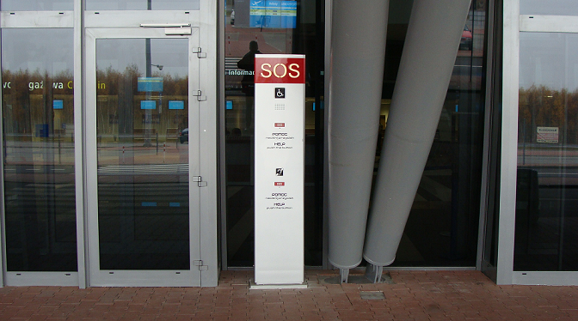

Notification Panels in front of the EXIT / ARRIVALS of the PASSENGER TERMINAL 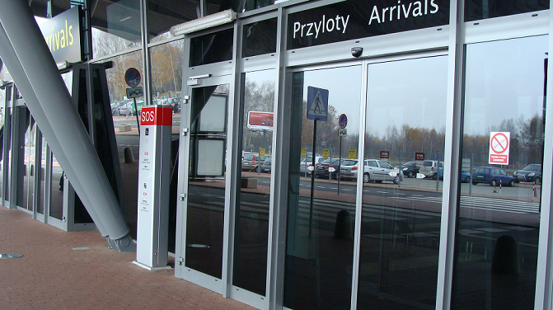

NOTIFICATION PANELS SOS
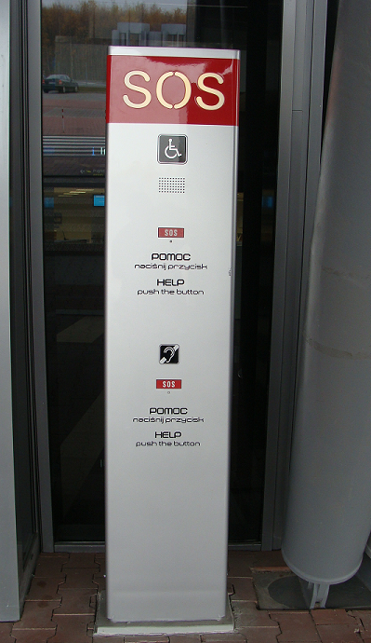
GENERAL AVIATION TERMINAL including the NOTIFICATION PANELS SOS
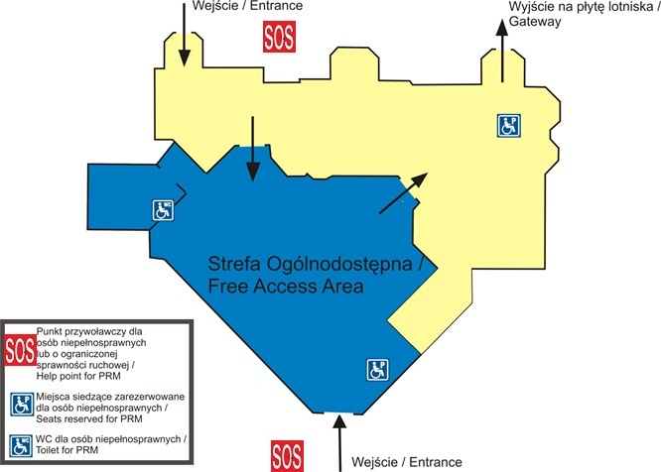
PASSENGER TERMINAL including the NOTIFICATION PANELS SOS
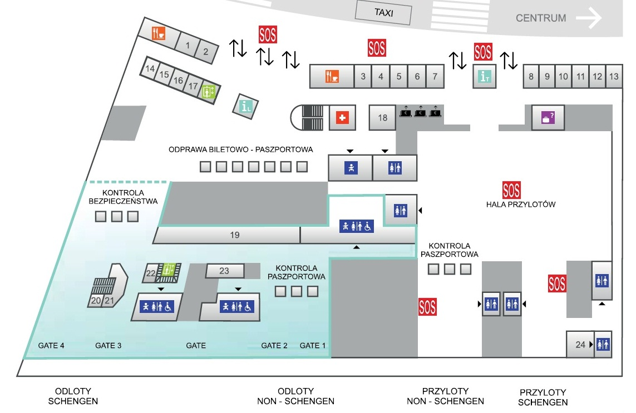

REGULATION (EC) No 1107/2006 OF THE EUROPEAN PARLIAMENT AND OF THE COUNCIL of 5 July 2006
EC 1107/2006
EC 1107/2006

